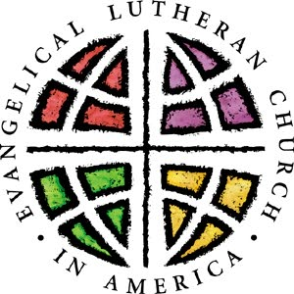
Christ Lutheran Church
2959 Queen Avenue
Slayton, Minnesota 56172
slaytonchristlutheran@gmail.com
507-836-8291

We will seek God’s will, share God’s love,
and serve as Christ’s people.

September 1, 2023

Blessings from Christ Lutheran Church:

Christ Lutheran Church will begin confirmation classes, starting again this fall. Your family is receiving this letter because you have a child of confirmation age, and we want to ensure you have the information you need to ensure their critical journey of discovery and education about the teachings of Christ.

This year, Greg and Nancy Moberg will again be coordinating and leading confirmation classes. They have an exciting curriculum planned, using resources from the ELCA and SWMN Synod. Pastors Chad Duffy will be assisting.

We’re excited to move forward with confirmation, knowing that the Lord will guide our teachers and students.

Please call the church office to let Bobbi-Jo know how many will be attending classes.
Thank you!

God’s peace from the Christ Lutheran Church Council

